CHAPTER 1
INTRODUCTION
  - OVERVIEW
A correct balance of nutrient intake is very important. When the body is deprived of essential nutrients, it can lead to serious disease and organ deterioration which can cause serious health issues. A correct balance of nutrient intake is very important, particularly in infants. When the body is deprived of essential nutrients, it can lead to serious disease and organ deterioration which can cause serious health issues in adulthood and also stress can affect how quickly food moves through your system and the way your intestines absorbs nutrients.
IoT (Internet of Things) systems allow users to achieve deeper automation, analysis, and integration within a system. They improve the reach of these areas and their accuracy. IoT utilizes existing and emerging technology for sensing, networking, and robotics. IoT exploits recent advances in software, falling hardware prices, and modern attitudes towards technology. Its new and advanced elements bring major changes in the delivery of products, goods, and services; and the social, economic, and political impact of those changes. The key features of IoT are,
- AI (Artificial Intelligence)
  - IoT loses its distinction without sensors. They act as defining instruments which transform IoT from a standard passive network of devices into an active system capable of real-world integration.
  - IoT exploits purpose-built small devices to deliver its precision, scalability, and versatility.
Deep learning is a class of machine learning algorithms that uses multiple layers to progressively extract higher level features from the raw input. For example, in image processing, lower layers may identify edges, while higher layers may identify the concepts relevant to a human such as digits or letters or faces.
Deep learning is part of a broader family of machine learning methods based on artificial neural networks. Deep learning architectures such as deep neural networks, deep belief networks, recurrent neural networks and convolutional neural networks have been applied to fields including computer vision, speech recognition, natural language processing, audio recognition, social network filtering, machine translation, bioinformatics, drug design, medical image analysis, material inspection and board game programs, where they have produced results comparable to and in some cases superior to human experts. Deep learning algorithms can be applied to unsupervised learning tasks. This is an important benefit because unlabelled data are more abundant than the labelled data. Examples of deep structures that can be trained in an unsupervised manner are neural history compressors and deep belief networks.
1.2 OBJECTIVE
The main objective of this project work is to propose automated nutritional monitoring content of food provided for both infants and for all age group of people and suggesting the calorie to be intake.
  - ORGANIZATION OF THE REPORT
Chapter 1 gives brief introduction and the core objective of designing the automated nutrition monitoring system.
Chapter 2 lists the various hardware component and their descriptions.
Chapter 3 deals with the overall program coding of the image processing of automated nutrition monitoring system.
Chapter 4 shows the final hardware module and explains about the connections and the working procedure of the module.
Chapter 5 discusses the result of the model and its advantages.
Chapter 6 gives the conclusion and future scope of the project.

1.2 LITERATURE SURVEY
Eigin Mendi, et-al., presented a paper on ‘A Mobile based Diet Monitoring System’, reports that personal diet management is key to fighting the obesity epidemic. Recent advances in smartphones and wearable sensor technologies have empowered automated food monitoring through food image processing and detection. In this paper, we present a new interactive mobile system that enables automated food recognition and assessment based on user food images and provides dietary. In addition to using techniques in computer vision and machine learning, one unique feature of this system is the realization of real-time energy balance monitoring through metabolic network simulation. This paper presents a proof-of-concept study of an image based classification system using smartphone applications specifically designed for automated food recognition and dietary intervention. Particularly, the entire framework can be broken down into four major parts that involve new strategies for comprehensive food image databases, classifiers capable for food item recognition, food volume estimation, and nutrient analysis that provide information for diet intervention. In addition, an energy-related metabolic model was implemented including all the meals or a random load have demonstrated the feasibility of the given model. Worth mentioning is the increasingly growing application of Deep Learning methods in image-based food recognition, which outperformed traditional approaches using handcrafted features.
H. Kalantarian, et-al., presented a paper on ‘A Survey of Diet Monitoring Technology’, reports that a significant number of problems related with aging have their origin in a deficient nutrition. Many elders suffer changes in their nutritional patterns and these changes can cause serious deterioration of their physical condition. Therefore, to be able to address nutritional problems in the elderly, their nutritional patterns must be recorded and analysed in an easy and efficient way. From a technological point of view, numerous works focus on monitoring the food intake, not only of elders but also of the general population. However, these works usually do not take into account the problems associated with an aging population. In this paper we present a survey of existing technological solutions for monitoring food intake. The problems related with nutrition are not limited exclusively to elderly people and children also suffer from nutritional disorders. Due to this, important research efforts are dedicated to various aspects related to feeding. Specifically, one of the most frequent aspects addressed by researchers is the monitoring of the people food intake. Food intake monitoring is intended to acquire information, such as the number of vitamins, minerals, and other substances ingested by a person. This information is then used for the identification of nutritional patterns that can help detect or address nutritional problems.
T. Vu, et-al., presented a paper on ‘Wearable Food Intake Monitoring Technologies, reports that wearable devices monitoring food intake through passive sensing is slowly emerging to complement self-reporting of users’ caloric intake and eating behaviours. Though the ultimate goal for the passive sensing of eating is to become a reliable gold standard in dietary assessment, it is currently showing promise as a means of validating self-report measures. Continuous food-intake monitoring allows for the validation and refusal of users’ reported data in order to obtain more reliable user information, resulting in more effective health intervention services. Recognizing the importance and strength of wearable sensors in food intake monitoring, there has been a variety of approaches proposed and studied in recent years. While existing technologies show promise, many challenges and opportunities discussed in this survey, still remain. This paper presents a meticulous review of the latest sensing platforms and data analytic approaches to solve the challenges of food-intake monitoring, ranging from ear-based chewing and swallowing detection systems that capture eating gestures to wearable cameras that identify food types and caloric content through image processing techniques. This paper focuses on the comparison of different technologies and approaches that relate to user comfort, body location, and applications for medical research. We identify and summarize the forthcoming opportunities and challenges in wearable food intake monitoring technologies. This paper presents a review of current wearable technologies of food intake monitoring, a crucial process in daily human activities determining wide ranges of bodily functions, such as amino acid production, eating behaviour and eating-related diseases. The efficient food type classification and advancing an effective signal processing procedure. If the existing challenges can be addressed, wearable sensors in food intake monitoring will play a significant role in improving overall human healthcare.

CHAPTER 2
HARDWARE COMPONENTS
2.1 INTRODUCTION
This chapter explains the components and devices that are used in this module. The proposed model contains the hardware components like,
- Raspberry Pi 3 model B+
- Bluetooth
- Arduino
- Analog to Digital Converter
- Load Cell
- LCD Display
- Webcam

Raspberry Pi 3 model B+ is a small board computer, introduced by Raspberry Pi foundation in 14th March 2018 and is the most recent version of the Pi boards. It is capable of playing 1080p MP4 video at 60 frames per second (with a bitrate of about 5400Kbps), boosting the Pi's media center credentials. The Bluetooth is a communication device, which is capable of transferring the information. Bluetooth is a wireless technology standard used for exchanging data between fixed and mobile devices over short distances using short-wavelength UHF radio waves in the industrial, scientific and medical radio bands, from 2.400 to 2.485 GHz, and building personal area networks (PANs). It was originally conceived as a wireless alternative to RS-232 data cables. A load cell is an electro-mechanical sensor used to measure force or weight. Load Cells are incredibly versatile devices that offer accurate and robust performance across a diverse range of applications. It’s no surprise that they have become essential to many industrial and commercial processes, from automating car manufacturing to weighing your shopping at the checkout. It has a simple yet effective design which relies upon the well-known transference between an applied force, material deformation and the flow of electricity.
Arduino is an open-source hardware and software company, user community that designs and manufactures single-board microcontrollers and microcontroller kits for building digital devices. The boards are equipped with sets of digital and analog input/output (I/O) pins that may be interfaced to various expansion boards ('shields') or breadboards (For prototyping) and other circuits. The boards feature serial communications interfaces, including Universal Serial Bus (USB) on some models, which are also used for loading programs from personal computers.
An analog-to-digital converter (ADC, A/D, or A-to-D) is a system that converts an analog signal, such as a sound picked up by a microphone or light entering a digital camera, into a digital signal. An ADC may also provide an isolated measurement such as an electronic device that converts an input analog voltage or current to a digital number representing the magnitude of the voltage or current. Typically the digital output is a two's complement binary number that is proportional to the input, but there are other possibilities. LCD (Liquid Crystal Display) is a type of flat panel display which uses liquid crystals in its primary form of operation. LCDs were a big leap in terms of the technology they replaced, which include light-emitting diode (LED) and gas-plasma displays.

2.2 RASPBERRY PI 3 MODEL B+
2.2.1 Introduction
Raspberry Pi 3 model B+ is a small board computer, introduced by Raspberry Pi foundation in 14th March 2018 and is the most recent version of the Pi boards. It is a modified form of its predecessor Raspberry Pi 3 B that was introduced in 2016 and came with CPU, GPU, USP ports and I/O pins. Both versions are almost same in terms of functionality and technical specifications; however, there are some exceptions in the B+ model as it comes with USB boot, network boot, and Power over Ethernet option that are not present in the B model.
Technology has been evolved over time with the purpose of making lives easy and convenient. This device was a major development in the technology that made computer learning too easy that anyone with little effort can make their feet wet with the process.
The features of B+ version are almost same as B model; however, USB and Network Boot and Power over Ethernet facility only come with B+ model. Also, two extra USB ports are added to this device. The SoC (system on chip) combines both CPU and GPU on a single package and turns out to be faster than Pi 2 and Pi 3 models. Raspberry Pi comes with a wide range of applications and works as a regular computer in some cases like,
- Home Automation
- Controlling Robots
- Arcade Machine
- Tablet Computer

2.2.2 Raspberry Pi 3 Model B+ Specifications
These are the specifications of Raspberry Pi 3 Model B+ :
  - Chipset: Broadcom BCM2837
  - CPU: 1.2GHz quad-core 64-bit ARM cortex A53
  - Ethernet: 10/100 (Max throughput 100Mbps)
  - USB: Four USB 2.0 with 480Mbps data transfer
  - Storage: MicroSD card or via USB-attached storage
  - Wireless: 802.11n Wireless LAN (Peak transmit/receive throughput of 150Mbps), Bluetooth 4.1
  - Graphics: 400MHz VideoCore IV multimedia
  - Memory: 1GB LPDDR2-900 SDRAM
  - Expandability: 40 general purpose input-output pins
  - Video: Full HDMI port
  - Audio: Combined 3.5mm audio out jack and composite video
  - Camera interface (CSI)
  - Display interface (DSI)

2.2.2 Pin Configuration

Pin configuration of Raspberry Pi 3 Model B+ :
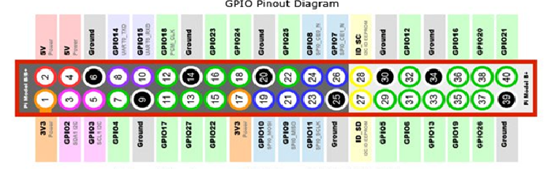
Fig 2.1 : Pin Configuration of Raspberry Pi 3 Model B+

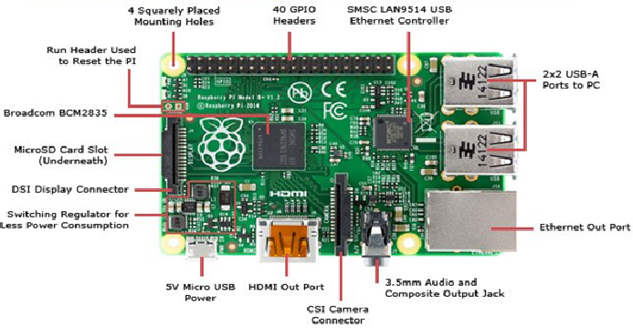
Fig. 2.2 : Hardware module of Raspberry Pi 3 model B+

2.2.3 Get Started with Raspberry Pi 3 Model B+

One thing to bear in mind is that the Pi by itself is just a bare board. You'll also need a power supply, a monitor or TV, leads to connect to the monitor--typically HDMI, and a mouse and keyboard.
Once you've plugged in all the cables, the easiest way for new users to get up and running on the Pi is to download the NOOBS (New Out-Of-Box Software) installer. Once the download is complete, follow the instructions and it will walk you through how to install an OS on the Pi. The installer makes it simple to set up various operating systems, although a good choice for first time users is the official OS Raspbian--although other operating systems are listed below.

The look and feel of Raspbian should be familiar to any desktop computer user. The OS, which is constantly being improved, recently had a graphical overhaul, and includes an optimized web browser, an office suite, programming tools, educational games, and other software.
2.2.4 Raspberry Pi 3 Model B+ different form its predecessors
The quad-core Raspberry Pi 3 is both faster and more capable than its predecessor, the Raspberry Pi 2. For those interested in benchmarks, the Pi 3's CPU--the board's main processor--has roughly 50-60 percent better performance in 32-bit mode than that of the Pi 2, and is 10x faster than the original single-core Raspberry Pi (based on a multi-threaded CPU benchmark in SysBench). Compared to the original Pi, real-world applications will see a performance increase of between 2.5x--for single-threaded applications--and more than 20x--when video playback is accelerated by the chip's NEON engine.
Unlike its predecessor, the new board is capable of playing 1080p MP4 video at 60 frames per second (with a bitrate of about 5400Kbps), boosting the Pi's media center credentials. That's not to say, however, that all video will playback this smoothly, with performance dependent on the source video, the player used and bitrate.
The Pi 3 also supports wireless internet out of the box, with built-in Wi-Fi and Bluetooth.
The latest board can also boot directly from a USB-attached hard drive or pen drive, as well as supporting booting from a network-attached file system, using PXE, which is useful for remotely updating a Pi and for sharing an operating system image between multiple machines.
2.3 BLUETOOTH
Bluetooth is a wireless technology standard used for exchanging data between fixed and mobile devices over short distances using short-wavelength UHF radio waves in the industrial, scientific and medical radio bands, from 2.400 to 2.485 GHz, and building personal area networks (PANs). It was originally conceived as a wireless alternative to RS-232 data cables.
Bluetooth is managed by the Bluetooth Special Interest Group (SIG), which has more than 35,000 member companies in the areas of telecommunication, computing, networking, and consumer electronics. The IEEE standardized Bluetooth as IEEE 802.15.1, but no longer maintains the standard. The Bluetooth SIG oversees development of the specification, manages the qualification program, and protects the trademarks. A manufacturer must meet Bluetooth SIG standards to market it as a Bluetooth device. A network of patents apply to the technology, which are licensed to individual qualifying devices. As of 2009, Bluetooth integrated circuit chips ship approximately 920 million units annually.
The name Bluetooth is the epithet of the tenth-century king Harald Bluetooth who united dissonant Danish tribes into a single kingdom. The implication is that Bluetooth unites communication protocols.
The idea of this name was proposed in 1997 by Jim Kardach of Intel, who developed a system that would allow mobile phones to communicate with computers. At the time of this proposal he was reading Frans G. Bengtsson's historical novel The Long Ships about Vikings and King Harald Bluetooth.


Fig 2.3 : Symbol of Bluetooth

2.3.1 Bluetooth history
The development of the "short-link" radio technology, later named Bluetooth, was initiated in 1989 by Nils Rydbeck, CTO at Ericsson Mobile in Lund, Sweden. The purpose was to develop wireless headsets, according to two inventions by Johan Ullman, SE 8902098-6, issued 1989-06-12 and SE 9202239, issued 1992-07-24. Nils Rydbeck tasked Tord Wingren with specifying and Jaap Haartsen and Sven Mattisson with developing. Both were working for Ericsson in Lund. In 1990, Jaap Haartsen was nominated by the European Patent Office for the European Inventor Award. From 1997 Örjan Johansson became the project leader and propelled the technology and standardization.
In 1997, Adalio Sanchez, then head of IBM ThinkPad product R&D, approached Nils Rybeck about collaborating on integrating a cell phone into a ThinkPad notebook. The two launched engineers from Ericsson and IBM to study the idea. The conclusion was that power consumption on cell phone technology at that time was too high to allow viable integration into a notebook and still achieve adequate battery life. Instead, the two companies agreed to integrate Ericsson's short-link technology on both a ThinkPad notebook and an Ericsson phone to accomplish the goal. Since neither IBM ThinkPad notebooks nor Ericsson phones were the market share leaders in their respective markets at that time, Adalio Sanchez and Nils Rydbeck agreed to make the short-link technology an open industry standard to permit each player maximum market access. Ericsson contributed the short-link radio technology, and IBM contributed patents around the logical layer. In May 1998, the Bluetooth SIG was launched with IBM and Ericsson as the founding signatories and a total of five members: Ericsson, Intel, Nokia, Toshiba and IBM.
The first consumer Bluetooth device launched in 1999. It was a hands-free mobile headset which earned the "Best of show Technology Award" at COMDEX. The first Bluetooth mobile phone was the Ericsson T36 but it was the revised T39 model which actually made it to store shelves in 2001. In parallel, IBM introduced the IBM ThinkPad A30 in October 2001 which was the first notebook with integrated Bluetooth.

2.3.2 Implementation
Bluetooth operates at frequencies between 2402 and 2480 MHz, or 2400 and 2483.5 MHz including guard bands 2 MHz wide at the bottom end and 3.5 MHz wide at the top. This is in the globally unlicensed (but not unregulated) industrial, scientific and medical (ISM) 2.4 GHz short-range radio frequency band. Bluetooth uses a radio technology called frequency-hopping spread spectrum. Bluetooth divides transmitted data into packets, and transmits each packet on one of 79 designated Bluetooth channels. Each channel has a bandwidth of 1 MHz. It usually performs 1600 hops per second, with adaptive frequency-hopping (AFH) enabled. Bluetooth Low Energy uses 2 MHz spacing, which accommodates 40 channels.

2.3.3 Communication and Connection
A master BR/EDR Bluetooth device can communicate with a maximum of seven devices in a piconet (an ad-hoc computer network using Bluetooth technology), though not all devices reach this maximum. The devices can switch roles, by agreement, and the slave can become the master (for example, a headset initiating a connection to a phone necessarily begins as master—as an initiator of the connection—but may subsequently operate as the slave).
The Bluetooth Core Specification provides for the connection of two or more piconets to form a scatternet, in which certain devices simultaneously play the master role in one piconet and the slave role in another.
At any given time, data can be transferred between the master and one other device (except for the little-used broadcast mode). The master chooses which slave device to address; typically, it switches rapidly from one device to another in a round-robin fashion. Since it is the master that chooses which slave to address, whereas a slave is (in theory) supposed to listen in each receive slot, being a master is a lighter burden than being a slave. Being a master of seven slaves is possible; being a slave of more than one master is possible. The specification is vague as to required behaviour in scatternets.

2.3.4 Uses
Bluetooth is a standard wire-replacement communications protocol primarily designed for low power consumption, with a short range based on low-cost transceiver microchips in each device. Because the devices use a radio (broadcast) communications system, they do not have to be in visual line of sight of each other; however, a quasi optical wireless path must be viable. Range is power-class-dependent, but effective ranges vary in practice. See the table "Ranges of Bluetooth devices by class".
Officially Class 3 radios have a range of up to 1 metre (3 ft), Class 2, most commonly found in mobile devices, 10 metres (33 ft), and Class 1, primarily for industrial use cases,100 metres (300 ft). Bluetooth Marketing qualifies that Class 1 range is in most cases 20–30 metres (66–98 ft), and Class 2 range 5–10 metres (16–33 ft).
The effective range varies depending on propagation conditions, material coverage, production sample variations, antenna configurations and battery conditions. Most Bluetooth applications are for indoor conditions, where attenuation of walls and signal fading due to signal reflections make the range far lower than specified line-of-sight ranges of the Bluetooth products.
Most Bluetooth applications are battery-powered Class 2 devices, with little difference in range whether the other end of the link is a Class 1 or Class 2 device as the lower-powered device tends to set the range limit. In some cases, the effective range of the data link can be extended when a Class 2 device is connecting to a Class 1 transceiver with both higher sensitivity and transmission power than a typical Class 2 device. Mostly, however, the Class 1 devices have a similar sensitivity to Class 2 devices. Connecting two Class 1 devices with both high sensitivity and high power can allow ranges far in excess of the typical 100m, depending on the throughput required by the application. Some such devices allow open field ranges of up to 1 km and beyond between two similar devices without exceeding legal emission limits.

Ranges of Bluetooth devices by class
Class | Max. permitted power |  | Typ. range  (m)
 | (mW) | (dBm)
1 | 100 | 20 | ~100
1.5  (BT 5 Vol 6 Part A Sect 3) | 10 | 10 | ~20
2 | 2.5 | 4 | ~10
3 | 1 | 0 | ~1
4 | 0.5 | −3 | ~0.5

Table 2.1 : Ranges of Bluetooth devices by class

2.3.5 List of applications
    - Wireless control and communication between a mobile phone and a handsfree headset. This was one of the earliest applications to become popular.
    - Wireless control of and communication between a mobile phone and a Bluetooth compatible car stereo system.
    - Wireless control of and communication with iOS and Android device phones, tablets and portable wireless speakers.
    - Wireless Bluetooth headset and Intercom. Idiomatically, a headset is sometimes called "a Bluetooth".
    - Wireless streaming of audio to headphones with or without communication capabilities.
    - Wireless streaming of data collected by Bluetooth-enabled fitness devices to phone or PC.
    - Wireless networking between PCs in a confined space and where little bandwidth is required.
    - Wireless communication with PC input and output devices, the most common being the mouse, keyboard and printer.
    - Transfer of files, contact details, calendar appointments, and reminders between devices with OBEX.
    - Replacement of previous wired RS-232 serial communications in test equipment, GPS receivers, medical equipment, bar code scanners, and traffic control devices.
    - For controls where infrared was often used.

2.4 LOAD CELL
A load cell is an electro-mechanical sensor used to measure force or weight. It has a simple yet effective design which relies upon the well-known transference between an applied force, material deformation and the flow of electricity. They are incredibly versatile devices that offer accurate and robust performance across a diverse range of applications. It’s no surprise that they have become essential to many industrial and commercial processes, from automating car manufacturing to weighing your shopping at the checkout. As technology explodes forward, many new and exciting applications are emerging that also stand to benefit from using load cells. New advances in robotics, haptics and medical prostheses, to name a few, all need effective ways to measure forces and weights. New types of load cells are continuously being designed to meet the needs of this ever-changing market.

2.4.1 Types of Load Cells
There are several types of load cells:
  - Bending beam: uses strain gauges to monitor the stress in the sensing element when spring element is subjected to a bending forces.^{[2]}
  - Pancake: low-profile load cells often used in vessel weighing; can be tension or compression.
  - Single point shear beam load cell: spring element fixed at one end and loaded on the other.
  - Double-ended shear beam: spring element fixed at both ends and loaded in the center.
  - Canister load cell: Cylindrical shaped spring element; can be used in both tension and compression.
  - S-type load cell: S-shaped spring element; can be used in both compression and tension.
  - Wire rope clamps: an assembly attached to a wire rope and measures its tension; commonly used in crane and hoist applications.
  - Tension link load cell: often used in crane and hoist weighing systems. Measures tension force only.

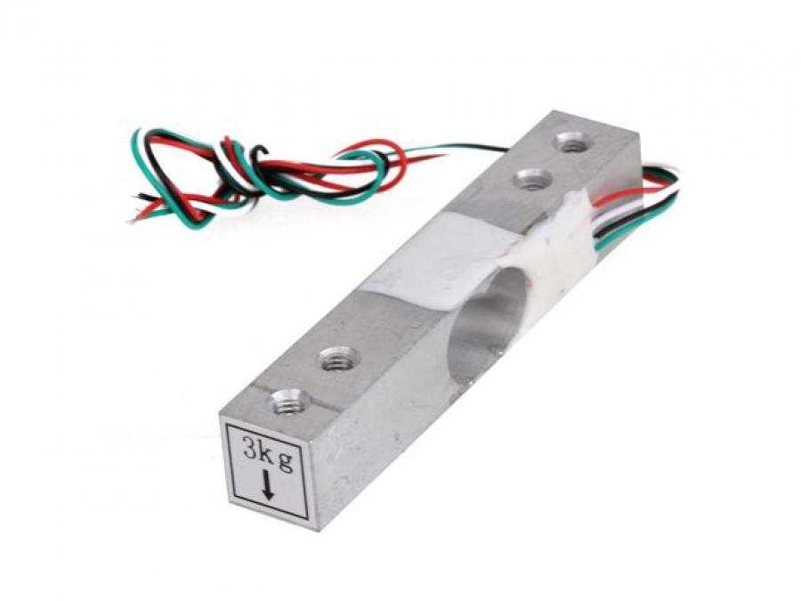
Fig 2.4 : Load Cell

2.4.2 Weighing Performances
Load cells are commonly used to measure weight in an industrial environment. They can be installed on hoppers, reactors...etc... to control their weight capacity, which is often of critical importance for an industrial process. Some performance characteristics of the load cells must be defined and specified to make sure they will cope with the expected service. Among those design characteristics are:
  - Combined Error
  - Resolution
  - Minimum verification interval

2.4.3 Calibration
Load cells are an integral part of most weighing systems in industrial, aerospace and automotive industries, enduring rigorous daily use. Over time, load cells will drift, age and misalign therefore they will need to be calibrated regularly to ensure accurate results are maintained. ISO9000 and most other standards specify a maximum period of around 18 months to 2 years between re-calibration procedures, dependant on the level of load cell deterioration. Annual re-calibration is considered best practice by many load cell users for ensuring the most accurate measurements.
Standard calibration tests will use linearity and repeatability as a calibration guideline as these are both used to determine accuracy. Calibration is conducted incrementally starting working in ascending or descending order. For example, if you have a 60 tonne load cell, then you way use specific test weights that measure in 5, 10, 20, 40 and 60 tonne increments – A five step calibration process is usually sufficient for ensuring your device is accurately calibrated. Repeating this five-step calibration procedure 2-3 times is recommended for consistent results.

2.4.4 Uses
Load cells are used in several types of measuring instruments such as laboratory balances, industrial scales, platform scales and universal testing machines. From 1993 the British Antarctic Survey installed load cells in glass fibre nests to weigh albatross chicks. Load cells are used in a wide variety of items such as the seven-post shaker which is often used to set up race cars.

2.5 ARDUINO
Arduino is an open-source hardware and software company, user community that designs and manufactures single-board microcontrollers and microcontroller kits for building digital devices. Its products are licensed under the GNU Lesser General Public License (LGPL) or the GNU General Public License (GPL), permitting the manufacture of Arduino boards and software distribution by anyone. Arduino boards are available commercially in preassembled form or as do-it-yourself (DIY) kits.
Arduino board designs use a variety of microprocessors and controllers. The boards are equipped with sets of digital and analog input/output (I/O) pins that may be interfaced to various expansion boards ('shields') or breadboards (For prototyping) and other circuits. The boards feature serial communications interfaces, including Universal Serial Bus (USB) on some models, which are also used for loading programs from personal computers. The microcontrollers can be programmed using C and C++ programming languages. In addition to using traditional compiler toolchains, the Arduino project provides an integrated development environment (IDE) based on the Processing language project.

2.5.1 Hardware
Arduino is open-source hardware. The hardware reference designs are distributed under a Creative Commons Attribution Share-Alike 2.5 license and are available on the Arduino website. Layout and production files for some versions of the hardware are also available.
Although the hardware and software designs are freely available under copyleft licenses, the developers have requested the name Arduino to be exclusive to the official product and not be used for derived works without permission. The official policy document on use of the Arduino name emphasizes that the project is open to incorporating work by others into the official product. Several Arduino-compatible products commercially released have avoided the project name by using various names ending in -duino.

2.5.2 Features
Most Arduino boards consist of an Atmel 8-bit AVR microcontroller (ATmega8, ATmega168, ATmega328, ATmega1280, ATmega2560) with varying amounts of flash memory, pins, and features. The 32-bit Arduino Due, based on the Atmel SAM3X8E was introduced in 2012. The boards use single or double-row pins or female headers that facilitate connections for programming and incorporation into other circuits. These may connect with add-on modules termed shields. Multiple and possibly stacked shields may be individually addressable via an I²C serial bus. Most boards include a 5 V linear regulator and a 16 MHz crystal oscillator or ceramic resonator. Some designs, such as the LilyPad, run at 8 MHz and dispense with the onboard voltage regulator due to specific form-factor restrictions.
Arduino microcontrollers are pre-programmed with a boot loader that simplifies uploading of programs to the on-chip flash memory. The default bootloader of the Arduino UNO is the optiboot bootloader. Boards are loaded with program code via a serial connection to another computer. Some serial Arduino boards contain a level shifter circuit to convert between RS-232 logic levels and transistor–transistor logic (TTL) level signals. Current Arduino boards are programmed via Universal Serial Bus (USB), implemented using USB-to-serial adapter chips such as the FTDI FT232. Some boards, such as later-model Uno boards, substitute the FTDI chip with a separate AVR chip containing USB-to-serial firmware, which is reprogrammable via its own ICSP header. Other variants, such as the Arduino Mini and the unofficial Boarduino, use a detachable USB-to-serial adapter board or cable, Bluetooth or other methods. When used with traditional microcontroller tools, instead of the Arduino IDE, standard AVR in-system programming (ISP) programming is used.

2.5.4 Pin configuration

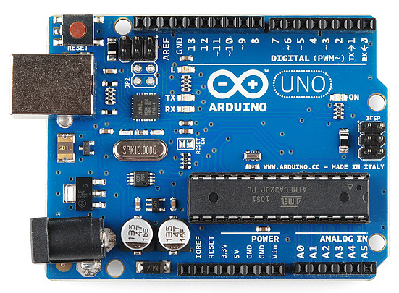
Fig 2.5 : Arduino board

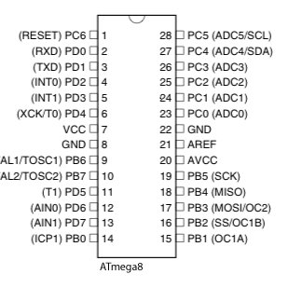
Fig 2.6 : Pin Configuration

2.5.5 Applications
- Arduboy, a handheld game console based on Arduino
- Arduinome, a MIDI controller device that mimics the Monome
- Ardupilot, drone software and hardware
- ArduSat, a cubesat based on Arduino.
- C-STEM Studio, a platform for hands-on integrated learning of computing, science, technology, engineering, and mathematics (C-STEM) with robotics.
- Data loggers for scientific research.
- OBDuino, a trip computer that uses the on-board diagnostics interface found in most modern cars
- OpenEVSE an open-source electric vehicle charger
- XOD, a visual programming language for Arduino

2.6 ANALOG TO DIGITAL CONVERTER
In electronics, an analog-to-digital converter (ADC, A/D, or A-to-D) is a system that converts an analog signal, such as a sound picked up by a microphone or light entering a digital camera, into a digital signal. An ADC may also provide an isolated measurement such as an electronic device that converts an input analog voltage or current to a digital number representing the magnitude of the voltage or current. Typically the digital output is a two's complement binary number that is proportional to the input, but there are other possibilities.
There are several ADC architectures. Due to the complexity and the need for precisely matched components, all but the most specialized ADCs are implemented as integrated circuits (ICs).
A digital-to-analog converter (DAC) performs the reverse function; it converts a digital signal into an analog signal.
An ADC converts a continuous-time and continuous-amplitude analog signal to a discrete-time and discrete-amplitude digital signal. The conversion involves quantization of the input, so it necessarily introduces a small amount of error or noise. Furthermore, instead of continuously performing the conversion, an ADC does the conversion periodically, sampling the input, limiting the allowable bandwidth of the input signal.
The performance of an ADC is primarily characterized by its bandwidth and signal-to-noise ratio (SNR). The bandwidth of an ADC is characterized primarily by its sampling rate. The SNR of an ADC is influenced by many factors, including the resolution, linearity and accuracy (how well the quantization levels match the true analog signal), aliasing and jitter. The SNR of an ADC is often summarized in terms of its effective number of bits (ENOB), the number of bits of each measure it returns that are on average not noise. An ideal ADC has an ENOB equal to its resolution. ADCs are chosen to match the bandwidth and required SNR of the signal to be digitized. If an ADC operates at a sampling rate greater than twice the bandwidth of the signal, then per the Nyquist–Shannon sampling theorem, perfect reconstruction is possible. The presence of quantization error limits the SNR of even an ideal ADC. However, if the SNR of the ADC exceeds that of the input signal, its effects may be neglected resulting in an essentially perfect digital representation of the analog input signal.

2.6.1 Accuracy
An ADC has several sources of errors. Quantization error and (assuming the ADC is intended to be linear) non-linearity are intrinsic to any analog-to-digital conversion. These errors are measured in a unit called the least significant bit (LSB). In the above example of an eight-bit ADC, an error of one LSB is 1/256 of the full signal range, or about 0.4%.

2.6.2 Nonlinearity
All ADCs suffer from nonlinearity errors caused by their physical imperfections, causing their output to deviate from a linear function of their input. These errors can sometimes be mitigated by calibration, or prevented by testing. Important parameters for linearity are integral nonlinearity and differential nonlinearity. These nonlinearities introduce distortion that can reduce the signal-to-noise ratio performance of the ADC and thus reduce its effective resolution.

2.6.3 Applications
Some of the applications of A/D converters are:
- Music recording
- Digital Signal Processing
- Scientific Instruments
- Rotary Encoder

2.7 LCD DISPLAY
LCD (Liquid Crystal Display) is a type of flat panel display which uses liquid crystals in its primary form of operation. LEDs have a large and varying set of use cases for consumers and businesses, as they can be commonly found in smartphones, televisions, computer monitors and instrument panels.
LCDs were a big leap in terms of the technology they replaced, which include light-emitting diode (LED) and gas-plasma displays. LCDs allowed displays to be much thinner than cathode ray tube (CRT) technology. LCDs consume much less power than LED and gas-display displays because they work on the principle of blocking light rather than emitting it. Where an LED emits light, the liquid crystals in an LCD produces an image using a backlight.
As LCDs have replaced older display technologies, LCDs have begun being replaced by new display technologies such as OLEDs.

2.7.1 LCD WORKING
A display is made up of millions of pixels. The quality of a display commonly refers to the number of pixels; for example, a 4K display is made up of 3840 x2160 or 4096x2160 pixels. A pixel is made up of three subpixels; a red, blue and green—commonly called RGB. When the subpixels in a pixel change colour combinations, a different colour can be produced. With all the pixels on a display working together, the display can make millions of different colours. When the pixels are rapidly switched on and off, a picture is created.
The way a pixel is controlled is different in each type of display; CRT, LED, LCD and newer types of displays all control pixels differently. In short, LCDs are lit by a backlight, and pixels are switched on and off electronically while using liquid crystals to rotate polarized light. A polarizing glass filter is placed in front and behind all the pixels, the front filter is placed at 90 degrees. In between both filters are the liquid crystals, which can be electronically switched on and off.
LCDs are made with either a passive matrix or an active matrix display grid. The active matrix LCD is also known as a thin film transistor (TFT) display. The passive matrix LCD has a grid of conductors with pixels located at each intersection in the grid. A current is sent across two conductors on the grid to control the light for any pixel. An active matrix has a transistor located at each pixel intersection, requiring less current to control the luminance of a pixel. For this reason, the current in an active matrix display can be switched on and off more frequently, improving the screen refresh time.
Some passive matrix LCD's have dual scanning, meaning that they scan the grid twice with current in the same time that it took for one scan in the original technology. However, active matrix is still a superior technology out of the two.

2.7.2 TYPES OF LCD
Types of LCDs include:
- Twisted Nematic (TN)- which are inexpensive while having high response times. However, TN displays have low contrast ratios, viewing angles and colour contrasts.
- In Panel Switching displays (IPS Panels)- which boast much better contrast ratios, viewing angles and colour contrast when compared to TN LCDs.
- Vertical Alignment Panels (VA Panels)- which are seen as a medium quality between TN and IPS displays.
- Advanced Fringe Field Switching (AFFS)- which is a top performer compared IPS displays in colour reproduction range.

2.7.3 LCD vs OLED vs QLED
LCDs are now being outpaced by other display technologies, but are not completely left in the past. Steadily, LCDs have been being replaced by OLEDs, or organic light-emitting diodes.
OLEDs use a single glass or plastic panels, compared to LCDs which use two. Because an OLED does not need a backlight like an LCD, OLED devices such as televisions are typically much thinner, and have much deeper blacks, as each pixel in an OLED display is individually lit. If the display is mostly black in an LCD screen, but only a small portion needs to be lit, the whole back panel is still lit, leading to light leakage on the front of the display.
An OLED screen avoids this, along with having better contrast and viewing angles and less power consumption. With a plastic panel, an OLED display can be bent and folded over itself and still operate. This can be seen in smartphones, such as the controversial Galaxy Fold; or in the iPhone X, which will bend the bottom of the display over itself so the display’s ribbon cable can reach in towards the phone, eliminating the need for a bottom bezel. However, OLED displays tend to be more expensive and can suffer from burn-in, as plasma-based displays do.
QLED stands for quantum light-emitting diode and quantum dot LED. QLED displays were developed by Samsung and can be found in newer televisions. QLEDs work most similarly to LCDs, and can still be considered as a type of LCD. QLEDs add a layer of quantum dot film to an LCD, which increases the colour and brightness dramatically compared to other LCDs. The quantum dot film is made up of small crystal semi-conductor particles. The crystal semi-conductor particles can be controlled for their colour output.
When deciding between a QLED and an OLED display, QLEDs have much more brightness and aren’t affected by burn-in. However, OLED displays still have a better contrast ratio and deeper blacks than QLEDs.
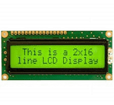
Fig 2.7 : LCD Display

2.7.4 APPLICATIONS
LCDs are used in a wide range of applications, including LCD televisions, computer monitors, instrument panels, aircraft cockpit displays, and indoor and outdoor signage. Small LCD screens are common in portable consumer devices such as digital cameras, watches, calculators, and mobile telephones, including smartphones.
LCD screens are also used on consumer electronics products such as DVD players, video game devices and clocks. LCD screens have replaced heavy, bulky cathode ray tube (CRT) displays in nearly all applications. LCD screens are available in a wider range of screen sizes than CRT and plasma displays, with LCD screens available in sizes ranging from tiny digital watches to very large television receivers.
LCDs are slowly being replaced by OLEDs, which can be easily made into different shapes, and have a lower response time, wider colour gamut, virtually infinite colour contrast and viewing angles, lower weight for a given display size and a slimmer profile (because OLEDs use a single glass or plastic panel whereas LCDs use two glass panels; the thickness of the panels increases with size but the increase is more noticeable on LCDs) and potentially lower power consumption (as the display is only "on" where needed and there is no backlight). OLEDs, however, are more expensive for a given display size due to the very expensive electroluminescent materials or phosphors that they use.
Also due to the use of phosphors, OLEDs suffer from screen burn-in and there is currently no way to recycle OLED displays, whereas LCD panels can be recycled, although the technology required to recycle LCDs is not yet widespread. Attempts to increase the lifespan of LCDs are quantum dot displays, which offer similar performance as an OLED display, but the Quantum dot sheet that gives these displays their characteristics cannot yet be recycled.

2.8 CONNECTING CABLES
A wire is a single, usually cylindrical, flexible strand or rod of metal. Used to bear mechanical loads or electricity and telecommunications signals. Wire is commonly formed by drawing the metal through a hole in a die or draw plate. Wire gauges come in various standard sizes, as expressed in terms of a gauge number. The term 'wire' is also used more loosely to refer to a bundle of such strands, as in "multistranded wire", which is more correctly termed a wire rope in mechanics, or a cable in electricity.
Wire comes in solid core, stranded, or braided forms. Although usually circular in cross-section, wire can be made in square, hexagonal, flattened rectangular, or other cross-sections, either for decorative purposes, or for technical purposes such as high-efficiency voice coils in loudspeakers. Edge-wound coil springs, such as the Slinky toy, are made of special flattened wire.

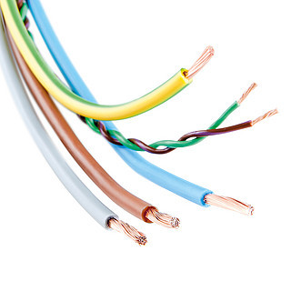
Fig 2.8 : Connecting wires and cables

Wire has many uses. It forms the raw material of many important manufacturers, such as the wire netting industry, engineered springs, wire-cloth making and wire rope spinning, in which it occupies a place analogous to a textile fibre. Wire-cloth of all degrees of strength and fineness of mesh is used for sifting and screening machinery, for draining paper pulp, for window screens, and for many other purposes. Vast quantities of aluminium, copper, nickel and steel wire are employed for telephone and data cables, and as conductors in electric power transmission, and heating. In the manufacture of stringed musical instruments and scientific instruments, wire is again largely used. Carbon and stainless spring steel wire have significant applications in engineered springs for critical automotive or industrial manufactured parts/components

2.9 WEBCAM
A webcam is a video camera that feeds or streams an image or video in real time to or through a computer to a computer network, such as the Internet. Webcams are typically small cameras that sit on a desk, attach to a user's monitor, or are built into the hardware. Webcams can be used during a video chat session involving two or more people, with conversations that include live audio and video. Webcam software enables users to record a video or stream the video on the Internet. As video streaming over the Internet requires a lot of bandwidth, such streams usually use compressed formats. The maximum resolution of a webcam is also lower than most handheld video cameras, as higher resolutions would be reduced during transmission. The lower resolution enables webcams to be relatively inexpensive compared to most video cameras, but the effect is adequate for video chat sessions.
The term "webcam" (a clipped compound) may also be used in its original sense of a video camera connected to the Web continuously for an indefinite time, rather than for a particular session, generally supplying a view for anyone who visits its web page over the Internet
Webcams typically include a lens, an image sensor, support electronics, and may also include one or even two microphones for sound.

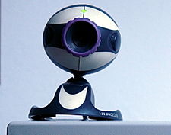

Fig 2.9 : Webcam
2.9.1 Uses
Webcams are used in many applications. These are mainly used in video conferencing, security purposes etc. Some of the uses and applications of webcams are:
- Health Care purposes
- Video Conferencing and Video Calling
- Video Monitoring
- Video Security

2.10 SUMMARY

The hardware components used in the proposed project work were interconnected with the help of wires and cables. The webcam is used to captures the type of food item placed on the load cell and sends the information to the raspberry pi B+. The module recognises the type of food item placed and displays on the monitor. The image processing work is done by the raspberry pi 3 B+ module. The load cell senses the weight of the food item placed on it and sends the information to the Arduino. Then the Arduino processes the information and sends the information to the LCD display. Then the LCD display displays the weight of the food item and the amount of calories present in the food item. The nutritional amount of the food items were predefined manually in the Arduino.

CHAPTER 3
PROGRAM CODING

3.1 INTRODUCTION
This chapter explains the program for image processing. The type of food item is recognized by the image processing technique. The image processing program is programmed in the raspberry pi 3 B+. The image processing program is written in python. The output is displayed on the monitor.

3.2 PROGRAM FOR IMAGE PROCESSING

# USAGE
# python real_time_object_detection.py --prototxt MobileNetSSD_deploy.prototxt.txt --model MobileNetSSD_deploy.caffemodel
# import the necessary packages
from imutils.video import VideoStream
from imutils.video import FPS
import numpy as np
import argparse
import imutils
import time
import cv2

# construct the argument parse and parse the arguments
ap = argparse.ArgumentParser()
ap.add_argument("-p", "--prototxt", required=True,
help="path to Caffe 'deploy' prototxt file")
ap.add_argument("-m", "--model", required=True,
help="path to Caffe pre-trained model")
ap.add_argument("-c", "--confidence", type=float, default=0.2,
help="minimum probability to filter weak detections")
args = vars(ap.parse_args())

# initialize the list of class labels MobileNet SSD was trained to
# detect, then generate a set of bounding box colors for each class

COLORS = np.random.uniform(0, 255, size=(len(CLASSES), 3))

# load our serialized model from disk
print("[INFO] loading model...")
net = cv2.dnn.readNetFromCaffe(args["prototxt"], args["model"])

# initialize the video stream, allow the cammera sensor to warmup,
# and initialize the FPS counter
print("[INFO] starting video stream...")
vs = VideoStream(src=0).start()
time.sleep(2.0)
fps = FPS().start()

# loop over the frames from the video stream
while True:
# grab the frame from the threaded video stream and resize it
# to have a maximum width of 400 pixels
frame = vs.read()
frame = imutils.resize(frame, width=400)

# grab the frame dimensions and convert it to a blob
(h, w) = frame.shape[:2]
blob = cv2.dnn.blobFromImage(cv2.resize(frame, (300, 300)),
0.007843, (300, 300), 127.5)

# pass the blob through the network and obtain the detections and
# predictions
net.setInput(blob)
detections = net.forward()

# loop over the detections
for i in np.arange(0, detections.shape[2]):
# extract the confidence (i.e., probability) associated with
# the prediction
confidence = detections[0, 0, i, 2]

# filter out weak detections by ensuring the `confidence` is
# greater than the minimum confidence
if confidence > args["confidence"]:
# extract the index of the class label from the
# `detections`, then compute the (x, y)-coordinates of
# the bounding box for the object
idx = int(detections[0, 0, i, 1])
box = detections[0, 0, i, 3:7] * np.array([w, h, w, h])
(startX, startY, endX, endY) = box.astype("int")

# draw the prediction on the frame
#label = "{}: {:.2f}%".format(CLASSES[idx],
#confidence * 100)
cv2.rectangle(frame, (startX, startY), (endX, endY),
COLORS[idx], 2)
y = startY - 15 if startY - 15 > 15 else startY + 15
#cv2.putText(frame, (startX, y),
#cv2.FONT_HERSHEY_SIMPLEX, 0.5, COLORS[idx], 2)

# show the output frame
cv2.imshow("Frame", frame)
key = cv2.waitKey(1) & 0xFF

# if the `q` key was pressed, break from the loop
if key == ord("q"):
break

# update the FPS counter
fps.update()

# stop the timer and display FPS information
fps.stop()
print("[INFO] elapsed time: {:.2f}".format(fps.elapsed()))
print("[INFO] approx. FPS: {:.2f}".format(fps.fps()))

# do a bit of cleanup
cv2.destroyAllWindows()
vs.stop()

3.3 SUMMARY

The image processing program is written in python and it is copied to the raspberry pi 3 B+ module. The output of image processing after capturing of the food item by webcam, is displayed on the monitor.

CHAPTER 4
AUTOMATED NUTRITION MONITORING SYSTEM
4.1 INTRODUCTION
This chapter shows the final hardware module and explains about the working procedure of the hardware module.

4.2 HARDWARE MODULE
The hardware module of the proposed project is shown below in Fig. 4.1. The webcam, monitor, mouse, keyboard and Arduino are connected to the raspberry pi 3 B+ with the help of connecting wires. The load cell, Bluetooth, switches and the analog to digital converter are connected to the Arduino with the help of connecting wires.

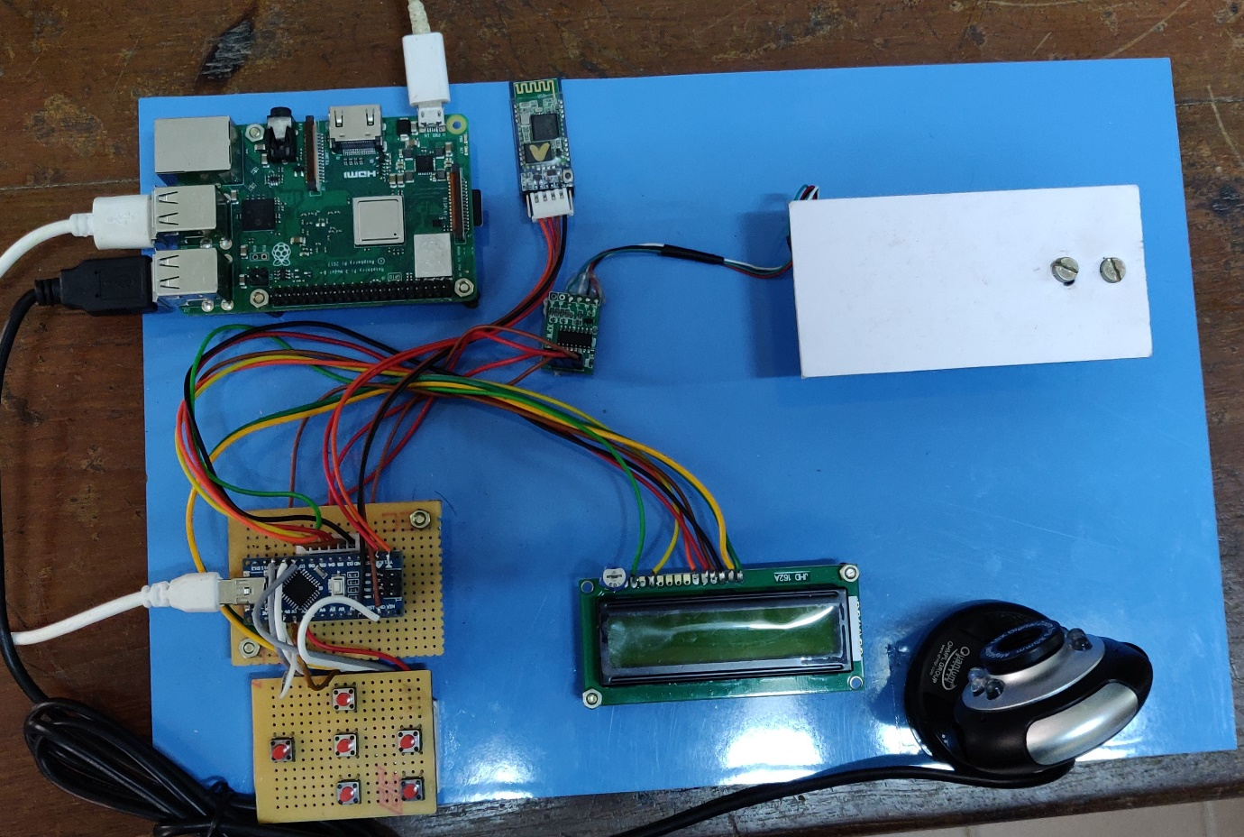

Fig 4.1 : Hardware module

4.3 WORKING

- The load cell is connected to the Analog to Digital convertor and from there it is connected to the mini Arduino.
- The power supply of 5v is connected to the raspberry pi board and keys for giving input is also set.
- A connection is established between raspberry pi and mini Arduino using an USB Cable.
- Camera is connected to the raspberry pi board and Bluetooth is connected to the mini Arduino.
- From Arduino the LCD display is connected.

COMPUTER DISPLAY
RASPBERRY PI
CAMARA

DETECTED FOOD OUTPUT DISPLAYED
FOOD TO BE DETECTED

Fig. 4.2. : Block diagram of the proposed project
Once the power supply is given to the Raspberry Pi, place the food item on the load cell. The food is detected by the webcam when the food is placed. The load cell calculates the amount of voltage in the food by using analog to digital converter. Then it sends the information to the mini Arduino. The mini Arduino send the information to display on LCD.
A male person requires about 3000 calories and for a female person requires 2000 calories per day and if a person falls under overweight he is supposed to reduce 1000 calories and if he falls on underweight category he is supposed to intake 1000 calories extra in order to fall on normal category. Based on this, the input is given manually to enter the person is male or female. The height and weight are entered manually to know whether the person is obese or under weighted. There is also another option to manually enter how much amount of calorie is present in the food. Based on these BMI values is calculated and displayed on the LCD.
The remaining calorie to be intaken for the day is shown in LCD and the entire detail of the person from the given input is displayed in the mobile by using Bluetooth.

4.3 SUMMARY
The hardware components used in the proposed project work were interconnected with the help of wires and cables. The webcam is used to captures the type of food item placed on the load cell and sends the information to the raspberry pi B+. The module recognises the type of food item placed and displays on the monitor. The image processing work is done by the raspberry pi 3 B+ module. The load cell senses the weight of the food item placed on it and sends the information to the Arduino. Then the Arduino processes the information and sends the information to the LCD display. Then the LCD display displays the weight of the food item and the amount of calories present in the food item. The nutritional amount of the food items were predefined manually in the Arduino. With the help of switches the weight and height of the person is given manually to the module. Therefore BMI values of the person is also calculated and displayed on the LCD display.

CHAPTER 5
RESULTS
5.1 INTRODUCTION
This chapter discusses about the result of the module, various advantage and applications of the nutrition monitoring system.

5.2 RESULT
Thus the nutrition monitoring system module is designed, constructed and implemented successfully using deep-learning approaches. The final output is shown in fig 5.1 and fig 5.2.
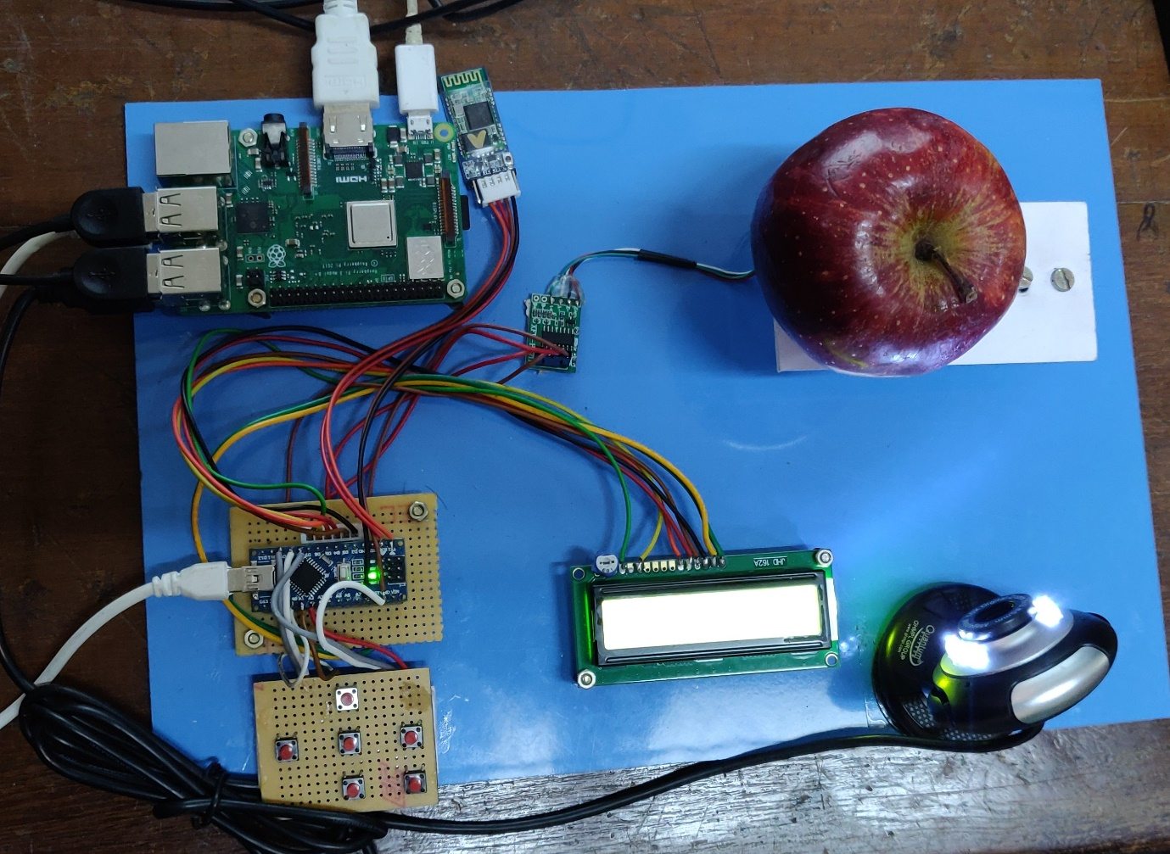
Fig 5.1 : Final output
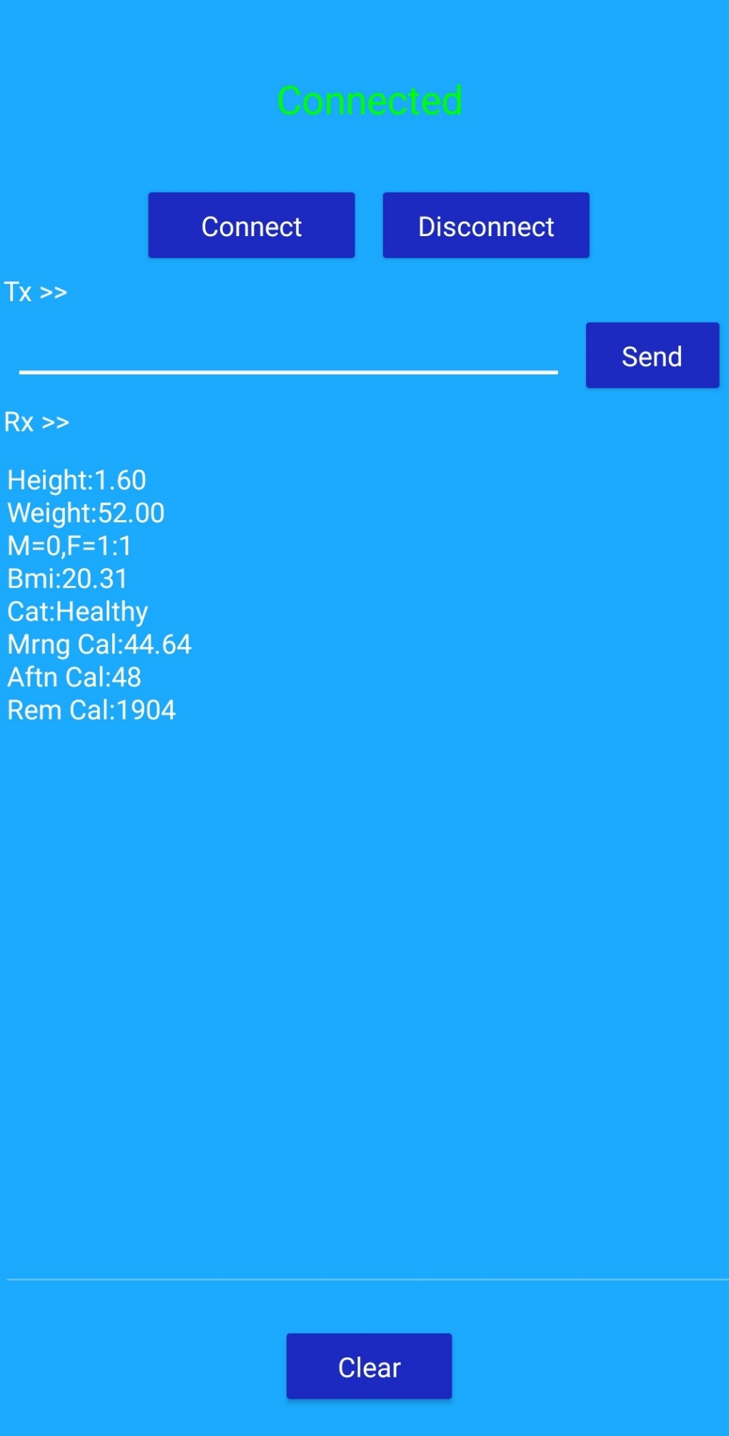
Fig 5.2 : Final output in the mobile
These are the some of the nutritional values obtained,
Input | Male | Female
Type | 0 | 1
Calorie per day | 3000 | 2000
Under weight (calories needed) | 3500 | 2500
Normal (calories needed) | 3000 | 2000
Overweight (calories needed) | 2500 | 1500

Table 5.1 : Nutritional values for a person in calorie

Parameter | Underweight | Normal | Overweight
Weight(kg) | 43 | 50 | 64
Height(cm) | 153 | 153 | 153
BMI value | 18.4 | 21.4 | 27.3

Table 5.2 : Processing and calculation of BMI

Category | BMI range
Underweight | Less than 18.4(<18.4)
Normal | Between 18.4 – 24.9
Overweight | Between 25 - 29.9
Obese | Greater than30 (>30)

Table 5.3 : BMI Range

5.3 SUMMARY
The hardware components used in the proposed project work were interconnected with the help of wires and cables. The webcam is used to captures the type of food item placed on the load cell and sends the information to the raspberry pi B+. The module recognises the type of food item placed and displays on the monitor. The image processing work is done by the raspberry pi 3 B+ module. The load cell senses the weight of the food item placed on it and sends the information to the Arduino. Then the Arduino processes the information and sends the information to the LCD display. Then the LCD display displays the weight of the food item and the amount of calories present in the food item. The nutritional amount of the food items were predefined manually in the Arduino. With the help of switches the weight and height of the person is given manually to the module. Therefore, BMI values of the person is also calculated and displayed on the LCD display.
The proposed system’s user interface is user friendly and can be easily understood by common people. This project suggests the calorie to be intaken to the end user. Based on the given amount of calorie the person can be transformed from either obesity or underweight to a normal person.

CHAPTER 6
CONCLUSION AND FUTURE SCOPE
5.1 CONCLUSION
The aging population is a phenomenon occurring not only in India, but also on the other countries. Also, according to the World Health Organization, from a medical point of view, age is associated with many diseases for which there are no effective treatments. However, the same study, showing that the aging population is associated with the increase in the prevalence of the diseases and speciﬁc related symptoms, indicates that all these could be delayed by the adoption of a healthy lifestyle. A healthy weight is a weight that lowers your risk for health problems. For most people BMI and waist size are good ways to tell if they are at a healthy weight. But reaching a healthy weight isn't just about reaching a certain number on the scale or a certain BMI. Having healthy eating habits is very important. If you want to get to a healthy weight and stay there, healthy lifestyle changes will work better than dieting. In this context, our study contributes to increase the quality of life, through the use of intelligent sensor and providing the amount of calorie to be intaken to maintain the proper health and an additional option is given to the user in the user interface, where the user can customize the entry. This helps in improving the overall efﬁciency of the system. This proposed project suggests the calorie to the end user to have a balanced diet based on the calculation of amount of nutrients for a person resulting in a perfect balanced diet preventing malnutrition and can be further used to maintain the diet balanced after reaching the normal BMI level.

5.2 FUTURE SCOPE
The proposed system can help in analysing the amount of nutrition consumed on an everyday basis and provide suggestions for the user to address malnutrition. With a cost effective sensor system and seamless data logging method, the proposed system can be an essential consumer electronic device which can be used in child care and healthcare system. This existing system can be further improvised by implementing IoT concepts and deep learning approaches for better image processing and suggesting meals instead of suggesting the calories.
REFERENCES
[1] H. Kalantarian, N. Alshurafa and M. Sarrafzadeh, “A Survey of Diet Monitoring Technology,” IEEE Pervasive Computers, volume 16, no. 1, pp. 57-65, January 2017.
[2] P. Sunderavadivel, K. Kesavan, L. Kesavan, S. P. Mohanty, E. Kougianous and M. K. Ganapathiraju, “Smart-Log: An Automated, Predictive Nutrition Monitoring System for Infants through IoT,” IEEE International Conference Consumer Electronics, 2018.
[3] A. R.Al-Ali, I. A. Zualkernan, M. Rashid, R. Gupta and M. Alikarar, “A Smart Home Energy Management System using IoT and Big Data Analytics Approach,” IEEE Transaction Consumer Electronics, volume 63, no. 4, pp. 426-434 November 2017.
[4] T. Vu, F. Lin, N. Alshurafa and W. Xu, “Wearable Food Intake Monitoring Technologies: A Comprehensive Review,” Computers, volume 6, no. 4, 2017.
[5] Eigin Mendi, Ocal Ozyavuz, Emrah Pekesen and Coskun Bayrak, “A Mobile based Diet Monitoring System,” IEEE International Workshop on Advances in Sensors and Interfaces IWASI, Conference paper, 2013.

